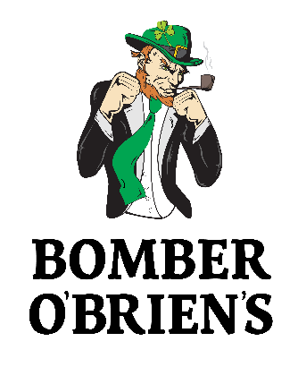
Party Menu
4621 Beck Ave. St. Louis, MO 63116
314-772-9501
www.bomberobriens.com

O’Brien’s Jumbo Chicken Wings with your choice of sauce
35 Count $45.00 70 Count $79.00
Giant Sub Sandwich (choice of ham & cheese, turkey & cheese or ham, turkey and cheese with lettuce and tomato)
4ft Sandwich $60.00 (Feeds 20-25 People)
House Salad mixed greens, tomatoes, cucumbers, cheese & house made croutons
Full Pan $55.00
Caesar Salad chopped romaine tossed in Caesar dressing, parmesan & house made croutons
Full Pan $50.00 (With Chicken $70.00)
Mostaccioli
Half Pan $35.00 Full Pan $60.00
Homemade Toasted Ravioli served with marinara sauce
50 Count $30.00 100 Count $55.00
Mama’s Pretzel Bites served with cheese sauce
75 Count $35.00 150 Count $65.00
Mini Tacos served with salsa and sour cream
50 Count $45.00 100 Count $75.00
Mozzarella Bites served with marinara sauce
50 Count $35.00 100 Count $65.00
Bomber Rolls served with Thousand Island
25 Count $45.00 50 Count $75.00
Pizza Chips served with marinara sauce
Half Pan $30.00 Full Pan $55.00
One Topping Pizza
16” $13.00

Drinks Packages:
- Draft (Bud, Bud Light & Bud Select), Wine, Well Drinks, Soda, Tea and Coffee (Minimum Party of 20 People, Excludes Shots)
2 Hours - $15/Person
3 Hours - $25/Person
2. Bottle Beer (Bud, Bud Light, Bud Select & Busch), Draft (Bud, Bud Light & Bud Select), Wine, Well Drinks, Soda, Tea and Coffee (Minimum Party of 20 People, Excludes Shots)
2 Hours - $20/Person
3 Hours - $30/Person
3. Open Bar including Call Drinks (Minimum Party of 20 People, Excludes Shots)
2 Hours - $25/Person
3 Hours - $35/Person

*For questions about additional items, per person in-house dinner rates and other in-house special packages is please contact us at 314-772-9501

A $200 deposit is required to secure the space and date of the event. Deposit will be applied towards the event’s final bill at the end of the party. In the event the party is canceled the deposit is non-refundable. 20% gratuity is added to the final bill.
Thank you for considering Bomber O’Brien’s!

